horizontal line

## Expiring a task

Expiration date/SLA due date on a task can be modified using a rest call.

In business central when we open up the task details, and navigate to Details tab

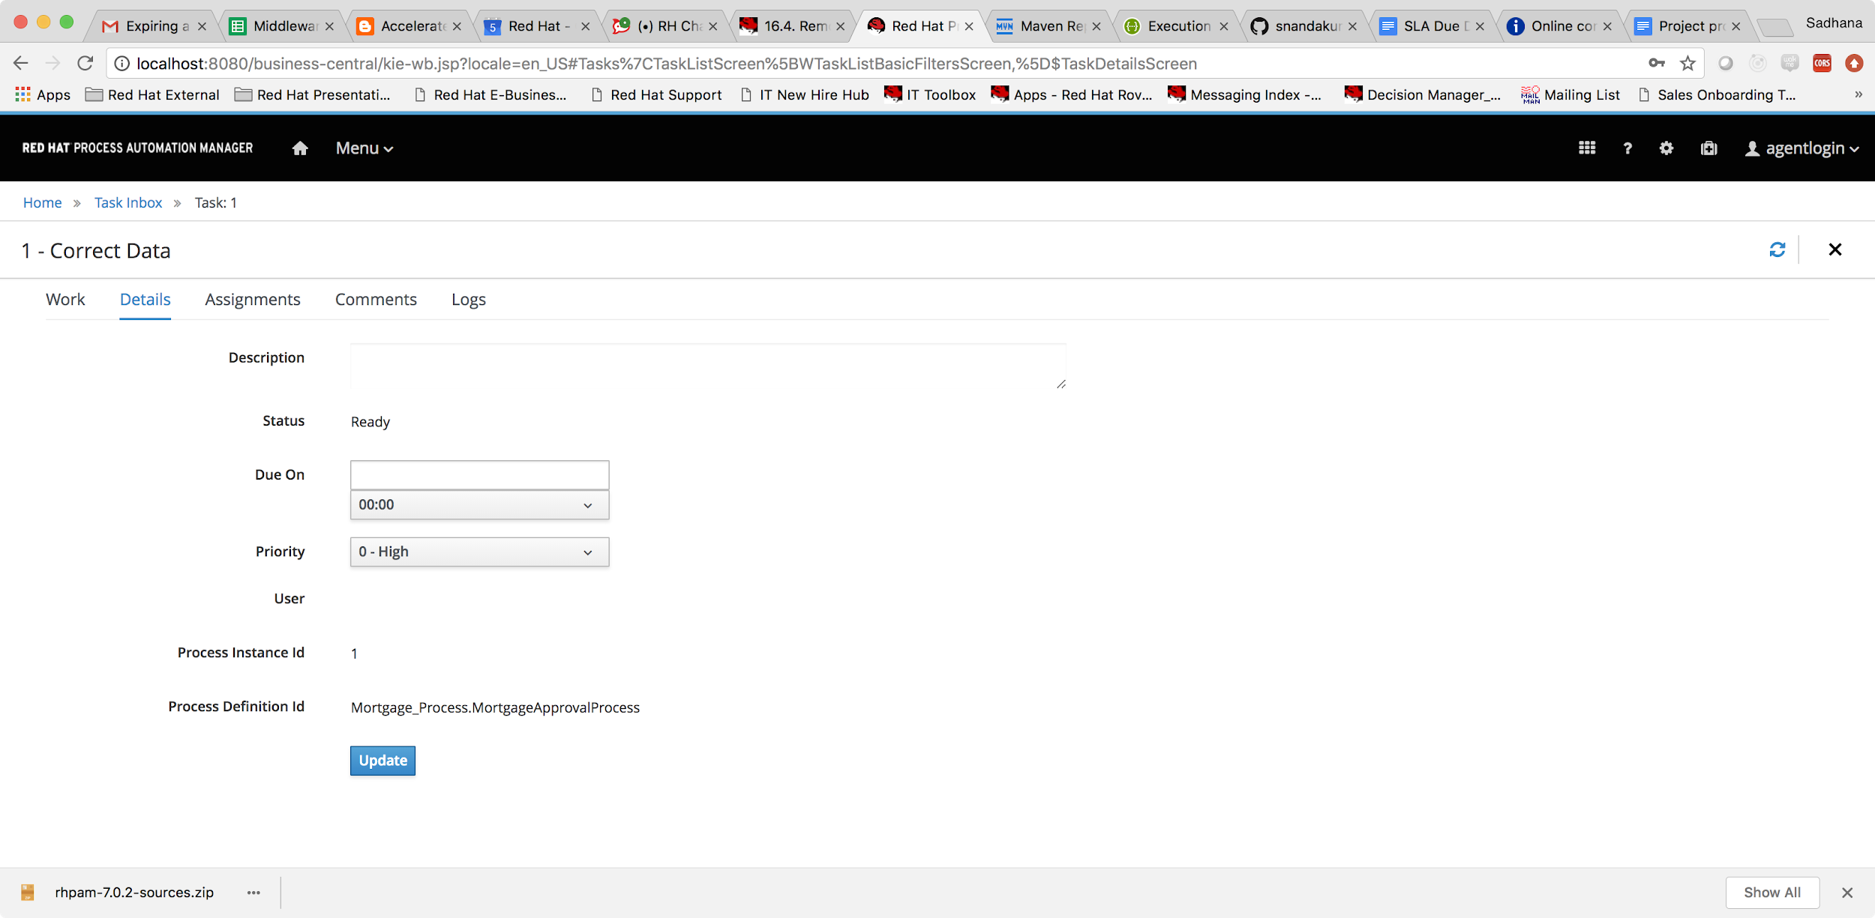

[PUT] /expiration

Request Type

Marshalled Date value.

Description

Updates the TASK_ID task expiration date and returns HTTP 201 if successful.

The rest call can be tested by opening up the swagger documentation at

<http://localhost:8080/kie-server/docs>

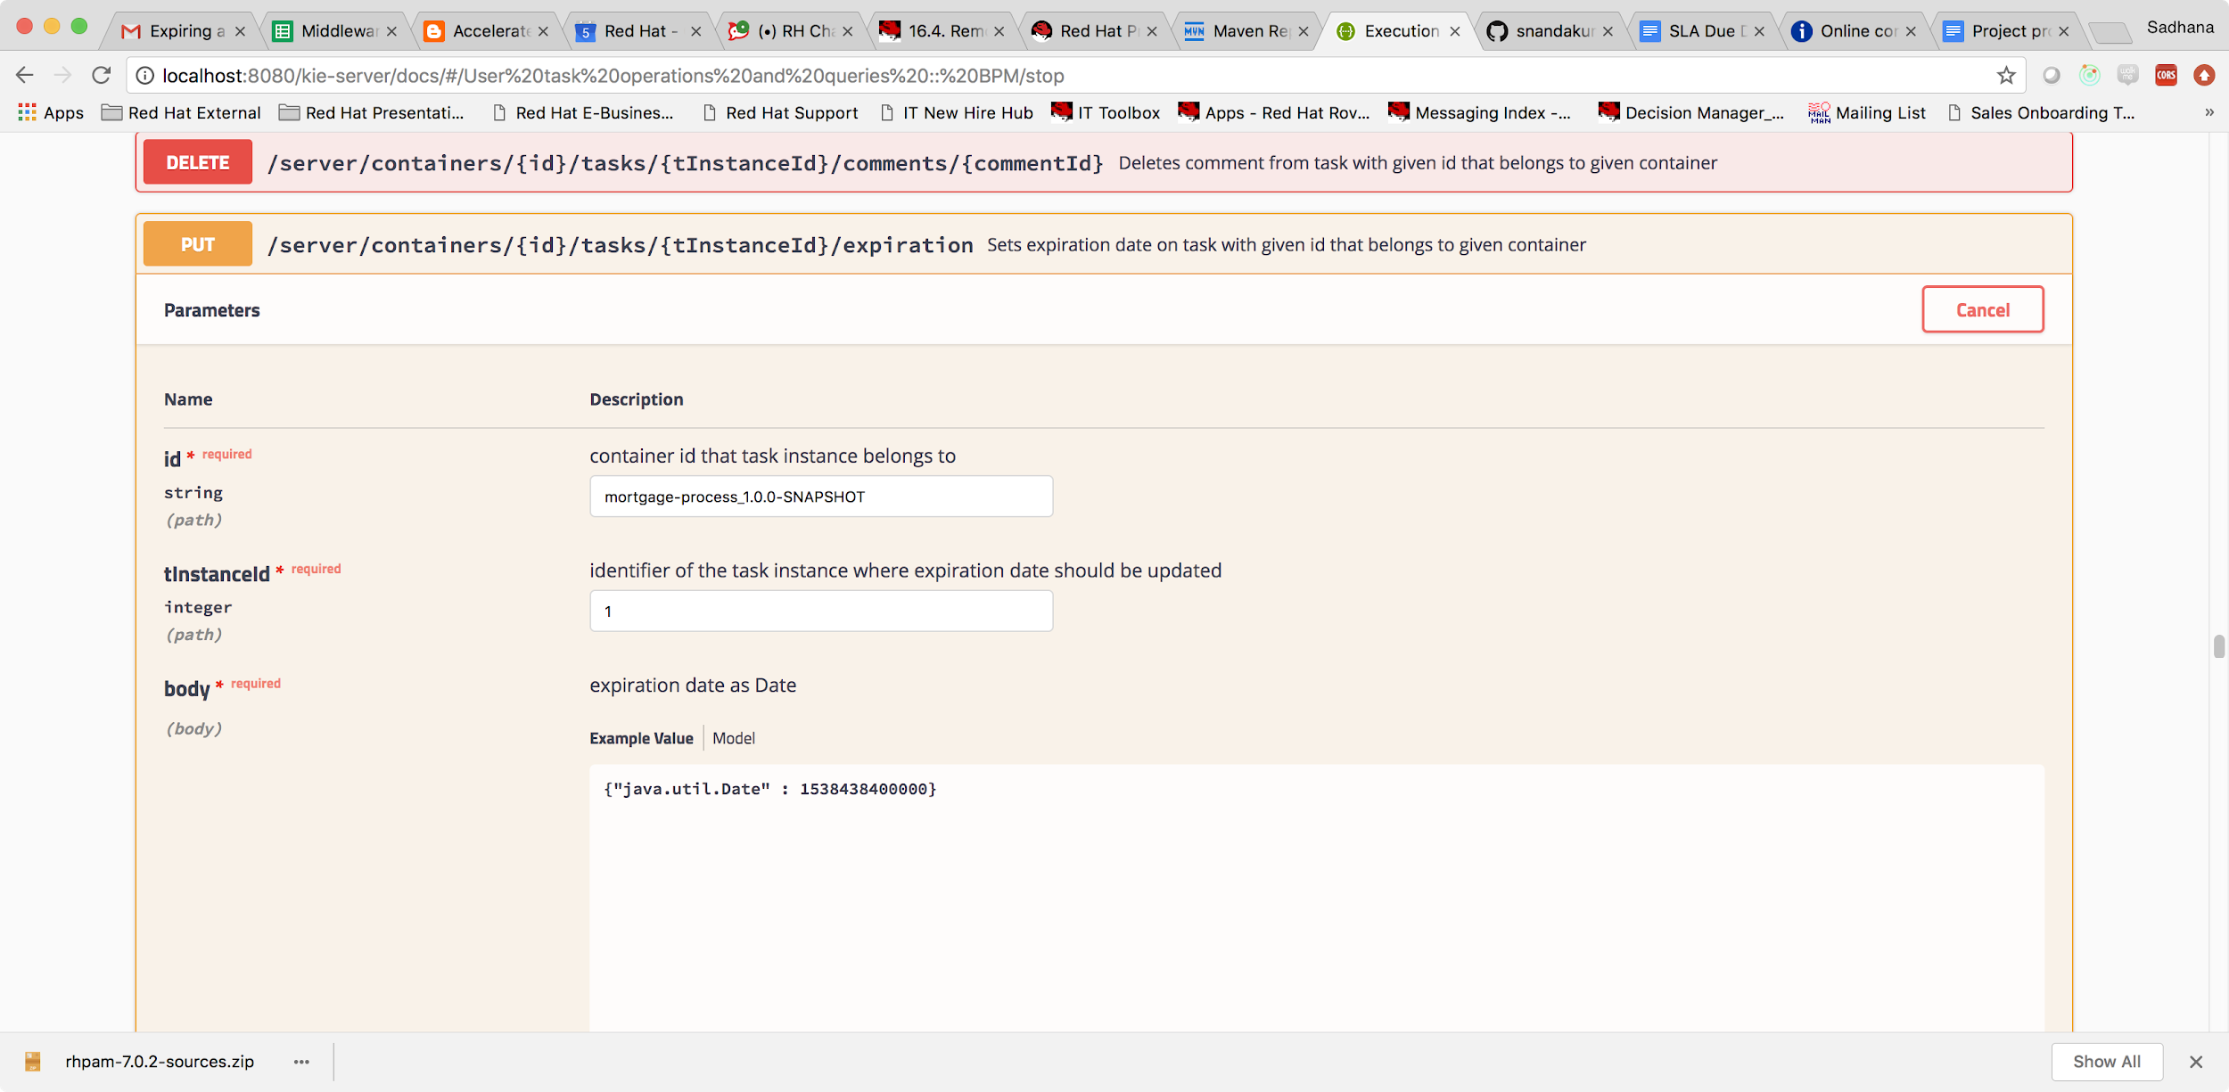

Passing in the container id of the task instance and the task instance id we can set the SLA due date as shown above.

curl -X PUT "http://localhost:8080/kie-server/services/rest/server/containers/mortgage-process_1.0.0-SNAPSHOT/tasks/1/expiration" -H "accept: application/xml" -H "content-type: application/json" -d "{\"java.util.Date\" : 1538438400000}"

Response : 201

Logging back in to business central we can see that the SLA due date on a task has been set to the expired date. If we had a SLA violation logic in place, this will then kick in.

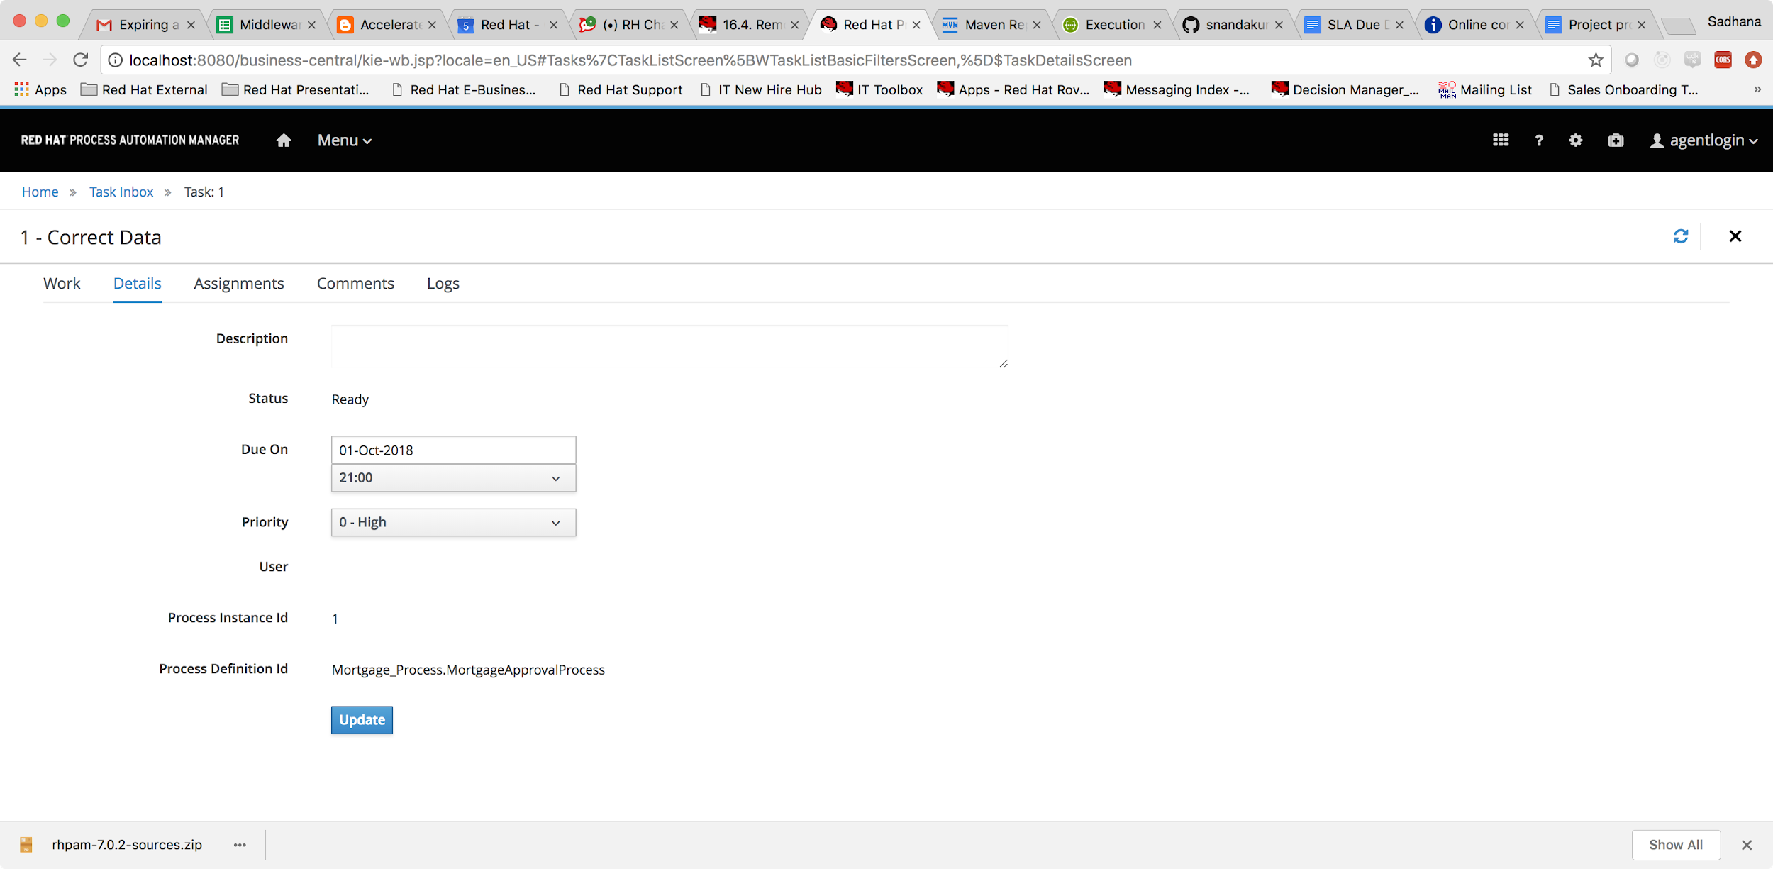

You can see that the SLA Due date has now been modified from the Rest call.

## Withdraw a Task

Assume that a task has been created, it is claimed and started by a user.

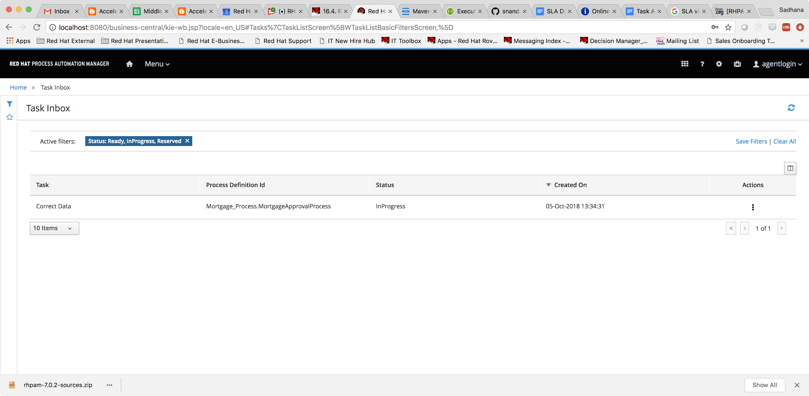

PUT   
/server/containers/{id}/tasks/{tInstanceId}/states/stopped  
Stops task with given id that belongs to given container

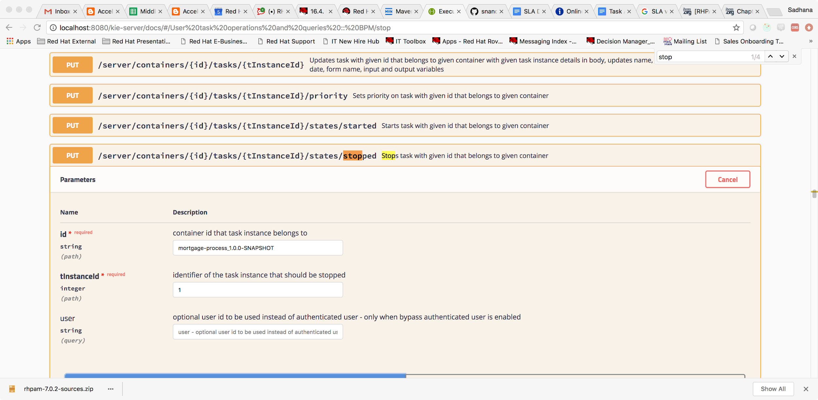

Invoking this call moves it from start state, back to the reserved state.

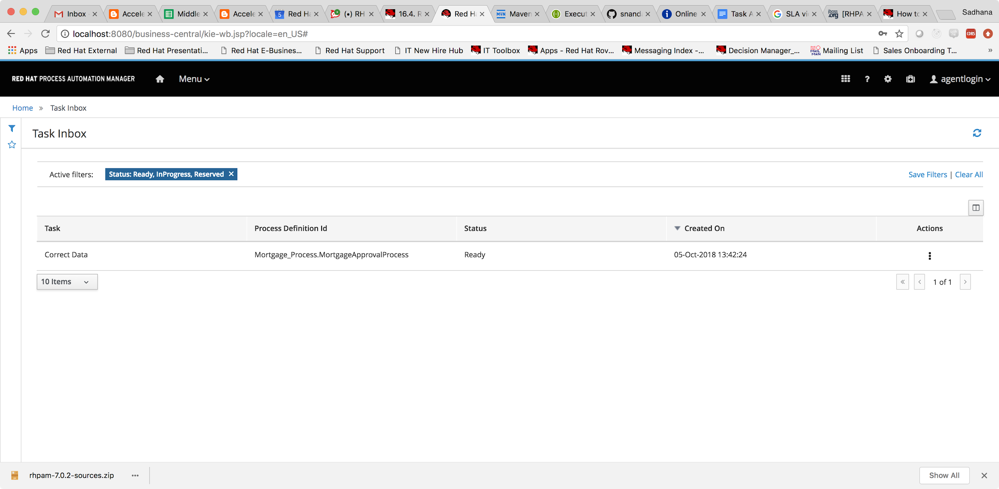

Also if you are looking to not execute a task anymore, then we could skip a task. Skipping a task requires that the skippable flag on the task be set to true.

PUT  
/server/containers/{id}/tasks/{tInstanceId}/skipable  
Sets skippable flag on task with given id that belongs to given container

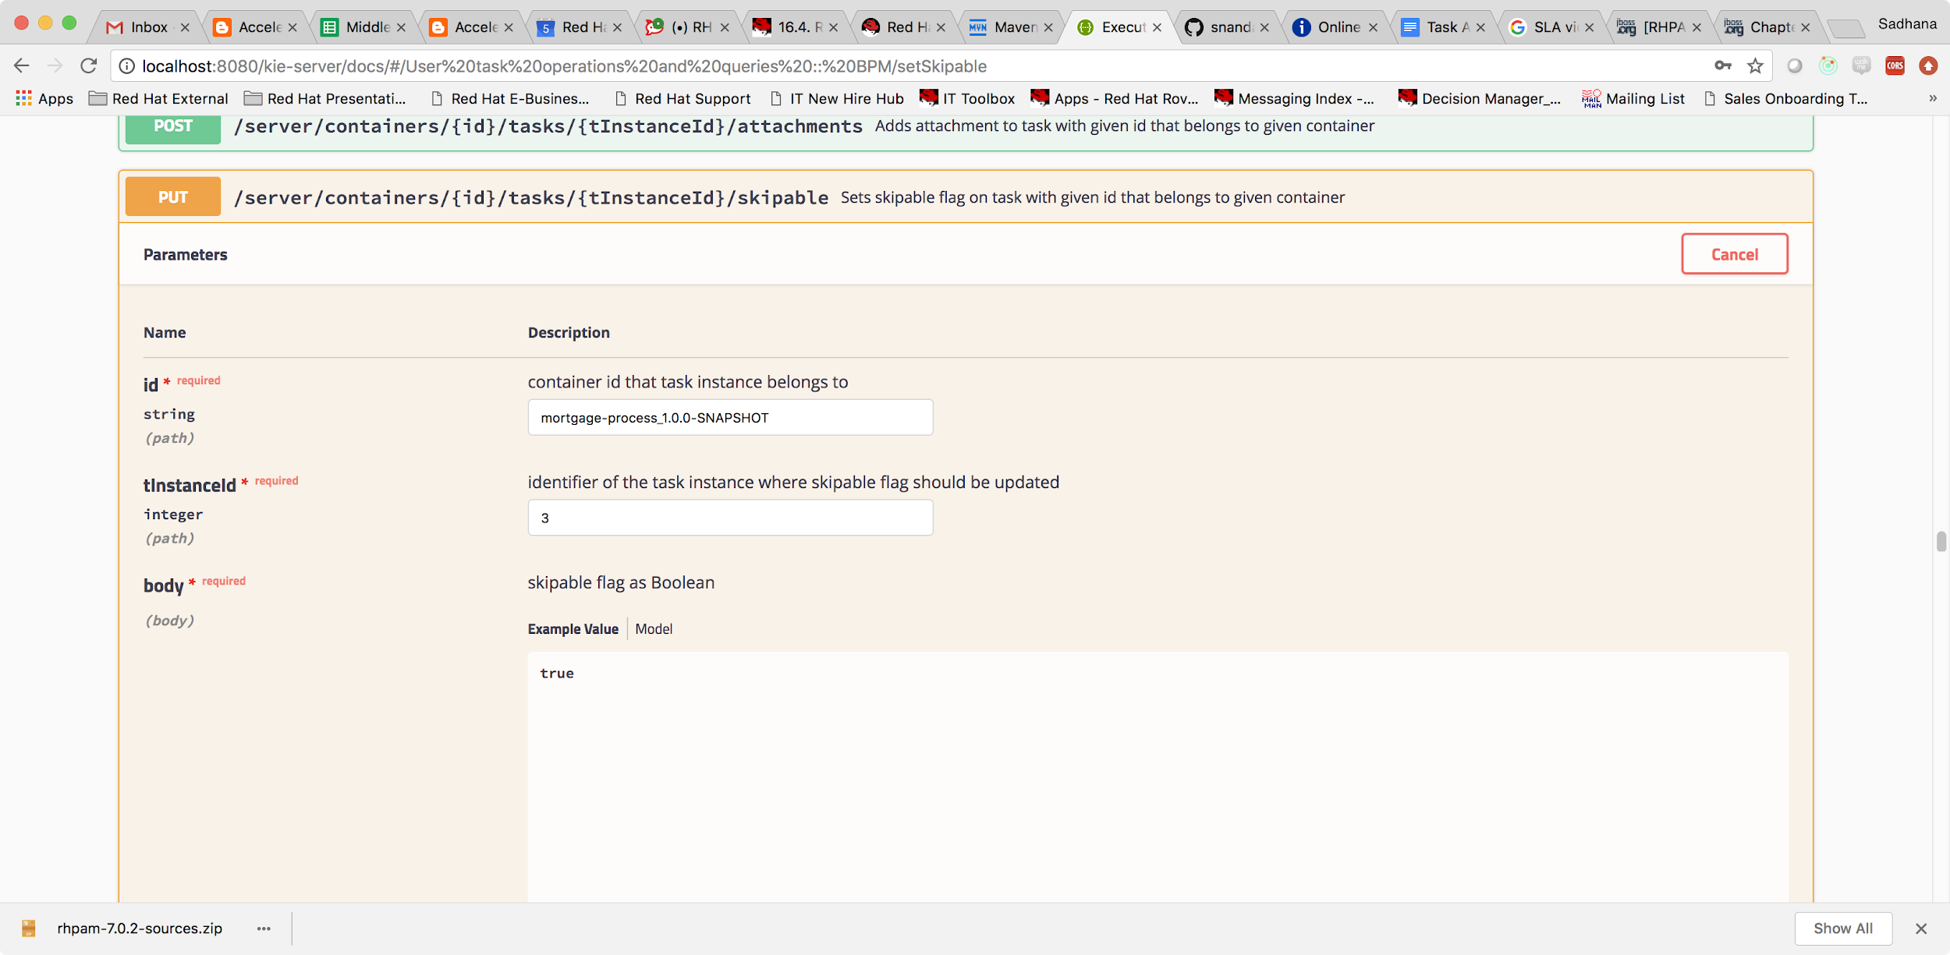

Once this is succesful we now invoke the call to skip the task.

/server/containers/{id}/tasks/{tInstanceId}/states/skipped  
Skips task with given id that belongs to given container

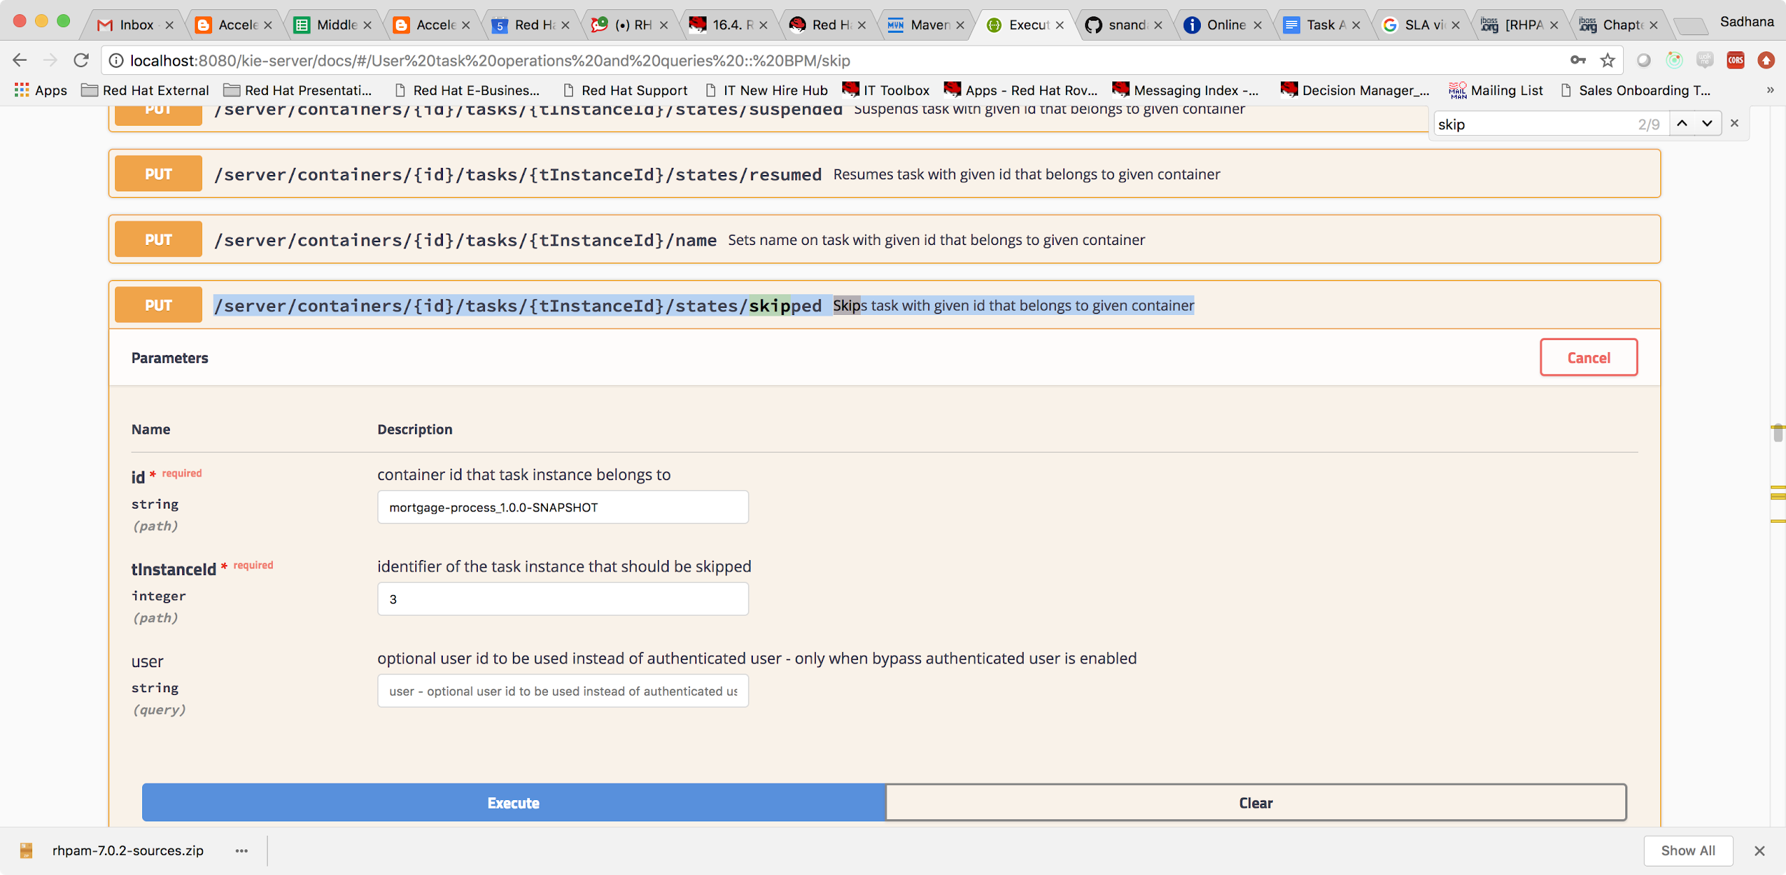

Once this is done, you can see that the task is now shown as obsolete on business central (will not execute)

